EXP 17 : CALCULATION OF PROCESSING GAIN AND GENERATION OF PN SEQUENCES FOR SPREAD SPECTRUM COMMUNICATION USING MATLAB SIMULATION

SOFTWARE USED : MATLAB SOFTWARE

CODE :
clc; clear; close all

N=7; reg=[1 0 0]; PN=zeros(1,N);

for k=1:N
PN(k)=reg(3);
fb=xor(reg(3),reg(1));
reg=[fb reg(1:2)];
end

PG=10*log10(N); % Processing gain in dB

subplot(2,1,1)
stairs(PN,'LineWidth',1.5),grid on
title('Generated PN Sequence')
xlabel('Chip Number'),ylabel('Bit')

subplot(2,1,2)
stem(1:N,2*PN-1,'filled'),grid on
title('Bipolar PN Sequence')
xlabel('Chip Number'),ylabel('Amplitude')

fprintf('PN Sequence: '); disp(PN)
fprintf('Processing Gain = %.2f dB\n',PG);
MODEL GRAPH :
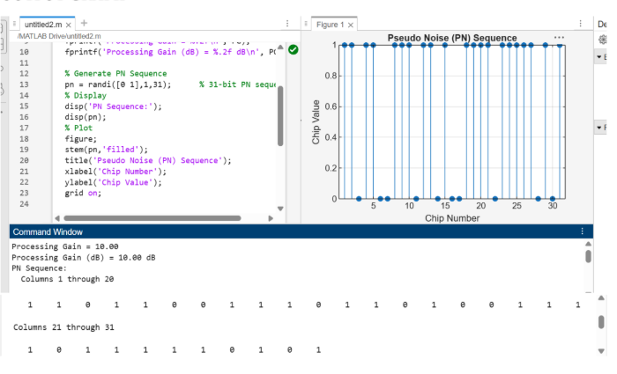

RESULT :
